Preschool - Application for Enrollment of New and Returning Students

School Year 2023-2024

Name of Child: ____________________________________ Nickname: ___________________

DOB: __________________ Age of Child: ________________

Address of Child: _______________________________________________________________

Parent Name(s) _________________________________________________________________

Phone Number: _______________________ Email address: ____________________________
Phone Number2: ______________________ Email address2: ___________________________

Select your class:

3-4 year olds AM Class (Little Lambs) 9am-11:30am Tuesday Thursday $150.00/month
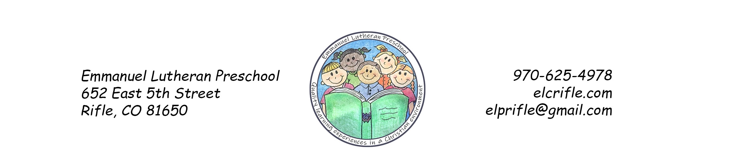

4-5 year olds AM Class (Busy Bees) 8:30am-11:30am Monday Wednesday Friday $215.00/ month

4-5 year olds PM Class (Lions) 12:45pm-3:30pm Monday Tuesday Wednesday Thursday
$240.00 per month

Please circle T-shirt Size XS S M L Unsure

Registration fee is $75.00 per school year and is non-refundable.

Please check if payment is attached.

Check number __________ and amount of check _________.

Cash and amount of cash _________.

Signature: _______________________________________________ Date: ____________

